ق1

Assignment 2

Deadline: Day 5/5/2024 @ 23:59

**[Total Mark for this Assignment is 8]**

***Object Oriented Programming***

***CS230***

**Instructions:**

* You must submit two separate copies **(one Word file and one PDF file)** using the Assignment Template on Blackboard via the allocated folder. These files **must not be in compressed format**.
* It is your responsibility to check and make sure that you have uploaded both the correct files.
* Zero mark will be given if you try to bypass the SafeAssign (e.g. misspell words, remove spaces between words, hide characters, use different character sets, convert text into image or languages other than English or any kind of manipulation).
* Email submission will not be accepted.
* You are advised to make your work clear and well-presented. This includes filling your information on the cover page.
* You must use this template, failing which will result in zero mark.
* You MUST show all your work, and text must not be converted into an image, unless specified otherwise by the question.
* Late submission will result in ZERO mark.
* The work should be your own, copying from students or other resources will result in ZERO mark.
* Use **Times New Roman** font for all your answers.

Student Details:

|  |  |  |
| --- | --- | --- |
|  |  |  |
| **Name:** Waleed AlAgeel  **CRN:** 20398 |  | **ID:** 230041499 |
|  |  |  |

# Question One

*Learning Outcome(s):*

*CLO4:*

Develop a program based on specification using programming language elements including syntax, data types, conditional statement, control structures.

***2 Marks***

Find the issues in the following Java code, then correct them.

public class Rectangular

{

private int length;

private int width;

public Rectangular(int length, int width)

{

this.length = length;

this.width = width;

}

public int area()

{

return length * width;

}

}

public class RectangularTest

{

public static void main (String[] args)

{

Rectangular r1 = new Rectangular(3,5);

System.out.println(r1.area());

}

}

There was an issue in the area function where the return type was String but, in the code, it was returning an int.  
  
Another issue was that in the main function of the program it was trying to use the area function, but it was out of scope.   
  
This might not be an issue, but I would rather mention it than lose marks for it. The classes should be split into 2 files, or the first class should not be public so it can be in the same file of the RectangularTest class and not require an import to use it.

# Question Two

***2 Marks***

*Learning Outcome(s): CLO4:*

Develop a program based on specification using programming language elements including syntax, data types, conditional statement, control structures.

1. Create a Java class for ***Student*** with the following requirements:

* Each student has two attributes: *Name and ID*.
* Create two constructors. One constructor without parameters to initialize all the instance variables to default values, and another constructor to initialize all the attributes to specific values.
* Add all setter and getter methods.

1. Create a ***tester class*** with the main method with the following requirements.

* Create two objects from *Student*class. Create the first object using the default constructor and the second object must set your name and ID.
* Print your name and ID using getter methods.

*Sample of the output:*

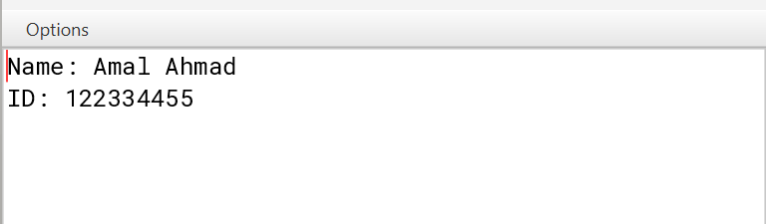

// Student Class Code

package Assignment2.Question2;

public class Student {

private String name;

private String id;

public Student() {

this.name = "Default Name";

this.id = "S00000000";

}

public Student(String name, String id) {

this.name = name;

this.id = id;

}

public String getName() {

return name;

}

public String getId() {

return id;

}

public void setName(String name) {

this.name = name;

}

public void setId(String id) {

this.id = id;

}

}

// Tester Class Code

package Assignment2.Question2;

public class Tester {

public static void main(String[] args) {

Student student1 = new Student();

Student student2 = new Student("Waleed AlAgeel", "S230041499");

System.out.println("Name: " + student2.getName());

System.out.println("ID: " + student2.getId());

}

}

# Question Three

***2 Marks***

*Learning Outcome(s): CLO4:*

Develop a program based on specification using programming language elements including syntax, data types, conditional statement, control structures.

Suppose you have the following 2 dimensions array:

int arr[][] = {

{ 10, 11, 12, 13, 14 },

{ 15, 16, 17, 18, 19 },

{ 20, 21, 22, 23, 24 },

{ 25, 26, 27, 28, 29 },

{ 30, 31, 32, 33, 34 }

};

With the the following rows and columns sizes:

static int rows= 5;

static int columns= 5;

Write a Java programs that uses takes arr[][] and reverse (mirror) all rows. For example, the first row should be as the following after you reverse it 14 13 12 11 10. A screenshot of your output should also be included in your answer and should display both the original array and the reversed array.

Sample output:

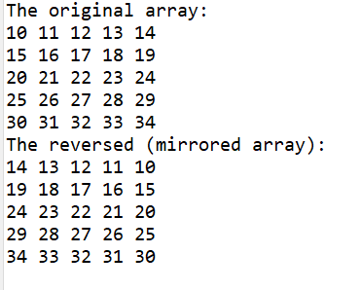

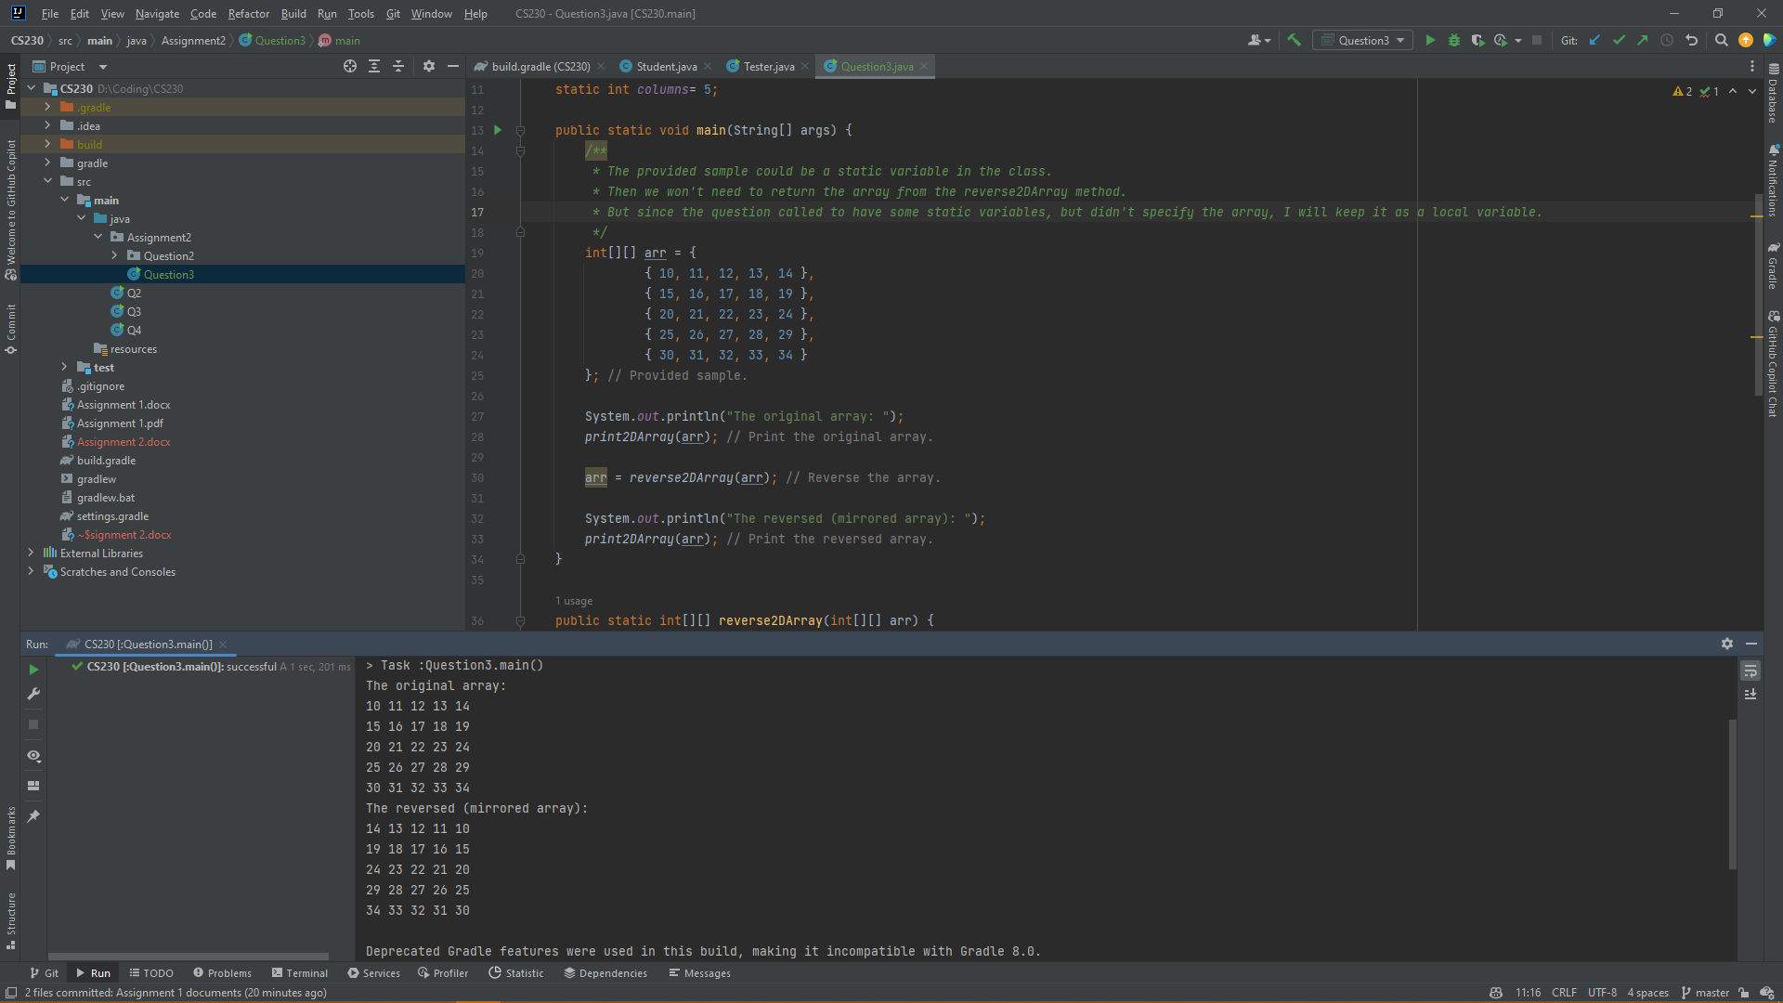

package Assignment2;

public class Question3 {

/**

* The function "can" handle any 2D array size even if it's not a square matrix.

* If we just remove the static variables and pass the array as a parameter, it will be more flexible.

* With the use of Array.length, we can get the number of rows and columns dynamically.

* But since the question provided the rows and columns as static variables, I will keep them as static variables.

*/

static int rows= 5;

static int columns= 5;

public static void main(String[] args) {

/**

* The provided sample could be a static variable in the class.

* Then we won't need to return the array from the reverse2DArray method.

* But since the question called to have some static variables, but didn't specify the array, I will keep it as a local variable.

*/

int[][] arr = {

{ 10, 11, 12, 13, 14 },

{ 15, 16, 17, 18, 19 },

{ 20, 21, 22, 23, 24 },

{ 25, 26, 27, 28, 29 },

{ 30, 31, 32, 33, 34 }

}; // Provided sample.

System.out.println("The original array: ");

print2DArray(arr); // Print the original array.

arr = reverse2DArray(arr); // Reverse the array.

System.out.println("The reversed (mirrored array): ");

print2DArray(arr); // Print the reversed array.

}

public static int[][] reverse2DArray(int[][] arr) {

for (int i = 0; i < rows; i++) {

for (int j = 0; j < columns / 2; j++) {

// This is the first element. We will swap it with the last element on the same row.

// In the next iteration, we will swap the second element with the second last element, and so on.

// If the array has an odd number of elements, the middle element will not be swapped.

int temp = arr[i][j];

arr[i][j] = arr[i][columns - j - 1]; // Left hand side element is now the right hand side element.

arr[i][columns - j - 1] = temp; // Right hand side element is now the left hand side element.

}

}

return arr;

}

public static void print2DArray(int[][] arr) {

for (int i = 0; i < rows; i++) {

for (int j = 0; j < columns; j++) {

System.out.print(arr[i][j] + " "); // We use print instead of println to print the elements in the same line.

}

System.out.println(); // Print a new line after each row.

}

}

}

# Question Four

***2 Marks***

Learning Outcome(s): CLO(4):

Develop a program based on specification using programming language elements including syntax, data types, conditional statement, control structures.

What is the output of the following Java program?

**public** **class** Exam

{

**static** **int** studyingHours = 31;

**private** **String** course = “OOP”;

**public** **void** compute(**int** studyingHours)

    {

        Exam e = **new** Exam();

**this**.studyingHours = 24;

course = “Math”;

        System.out.println("Exam.studyingHours: " + Exam.studyingHours);

        System.out.println("e.studyingHours: " + e.studyingHours);

        System.out.println("e.course: " + e.course);

        System.out.println("course: " + course);

    }

**public** **static** **void** main(String args[])

    {

        Exam e = **new** Exam();

        e.compute(31);

    }

}

Exam.studyingHours: 24 // Since the static int was changed just before.

e.studyingHours: 24 // This will change with the static int since it’s shared with all instances of the class Exam

e.course: OOP // This is accessing the class created in the start of the compute function which the default course for is OOP

course: Math // This is referencing the value of course in the local scope which is Math